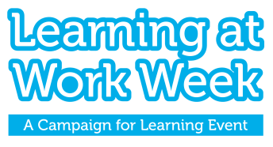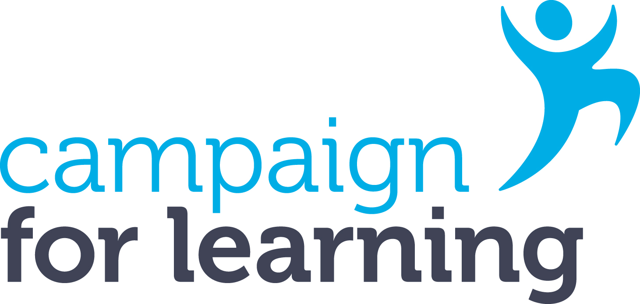
The Campaign for Learning
Learning at Work Week Impact Award
'Supporting Business and Organisational Goals'
Learning at Work Week offers an opportunity to support business goals and address organisational needs through, for example, designing special activities, launching new learning initiatives, testing new approaches and using the week to reinforce business values and communicate important messages.
The Campaign for Learning Impact Award for Learning at Work Week recognises one large* organisation and one SME** organisation that best demonstrate how their Learning at Work Week activities contributed to supporting their business and organisational goals. Judges will look for evidence of how you integrated your business or departmental goals into the planning and implementation of your Learning at Work Week activities. Judges are also keen to see how you have evaluated the impact of your activities, and how these have resulted in and/or will lead to longer term benefits. The judging criteria can be found on the last page of this entry form.
The award is free to enter and the deadline for submissions is Friday 19 July 2024. Please submit your application along with graphics, photos or media if available. Non submission of graphics, photos or media is not a disadvantage.
*Large organisations are defined here as having more than 250 employees
**SME organisations are defined here as having no more than 250 employees
About you and your organisation
(please note this section is for information only and will not be part of the judging criteria)
Name
Job title
Organisation
Address
Tel
Email
How many employees do you have?
How many employees participated in the event?
Section 1: Objectives
Which business goals or organisational needs did you support through Learning at Work Week? (100 words max)
What were your objectives for Learning at Work Week and how did these support your identified business goals and needs? (150 words max)

Section 2: Learning at Work Week activities
What activities did you design and deliver for Learning at Work Week and who were they aimed at in your organisation? (100 words max)

How did the activities support the achievement of your Learning at Work Week objectives? (150 words max)
Section 3: Promotion of your Learning at Work Week activities
How did you promote your Learning at Work Week activities? (200 words max)

How did your promotional activities support your Learning at Work Week objectives? (100 words max)

Section 4: Evaluation and outcomes
How were your events and activities monitored and evaluated? (150 words max)
What were the main outcomes and benefits for employees? (150 words max)
What were the main outcomes and benefits for your business or organisation? (150 words max)
Declaration
I confirm that all the information given in support of this entry is correct and I understand that information contained in this entry may be used for publicity purposes by the Campaign for Learning in accordance with the Data Protection Act and with, if required, your permission.
Signature
Date
By entering, you give Campaign for Learning permission to contact you about products and services which may be of interest. Please tick here if you do NOT wish to receive such messages.
Please submit your entry by email to the Learning at Work Week team at info@cflearning.org.uk
If you do not receive a confirmation of receipt, please email: jwright@cflearning.org.uk
Deadline for submissions: Friday 19 July 2024. Incomplete or late submissions will not be considered.
If you are successful, you will be notified by Friday 27 September 2024.
The judges’ decision is final and no correspondence or discussion will be entered into about the results.

JUDGING CRITERIA
To score 25/25 in the scoring system you will need to address the following criteria within each of the four sections in addition to telling us about your Learning at Work Week and organisation.
Section 1: Learning at Work Week objectives (5 marks)
- Clear identification of business goals and organisational needs (2 marks)
- Clear explanation of the link between your Learning at Work Week objectives and your business goals and organisational needs (3 marks)
Section 2: Learning at Work Week activities and supporting business goals/addressing organisational needs
(7 marks)
- How you designed and delivered your activities for your workplace audiences (including content, process, style and resources used (4 marks)
- How your activities supported the achievement of your Learning at Work Week objectives (3 marks)
Section 3: Promotion of your Learning at Work Week activities (7 marks)
- How you reached and persuaded your different workplace audiences to take part – include details of the communication channels used, the messages used to engage your workplace audiences, and the promotional materials used (4 marks)
- Innovative use of marketing (1 marks)
- How your promotion activities supported the achievement of your Learning at Work Week objectives (2 marks)

Section 4: Evaluation, outcomes and impact (6 marks)
- How you monitored and gathered feedback and evidence for evaluation including qualitative and quantitative evidence (3 marks)
- Identification of outcomes and benefits for employees and the organisation (3 marks)

